Walter Winchell: The Power of Gossip
PRESS KIT
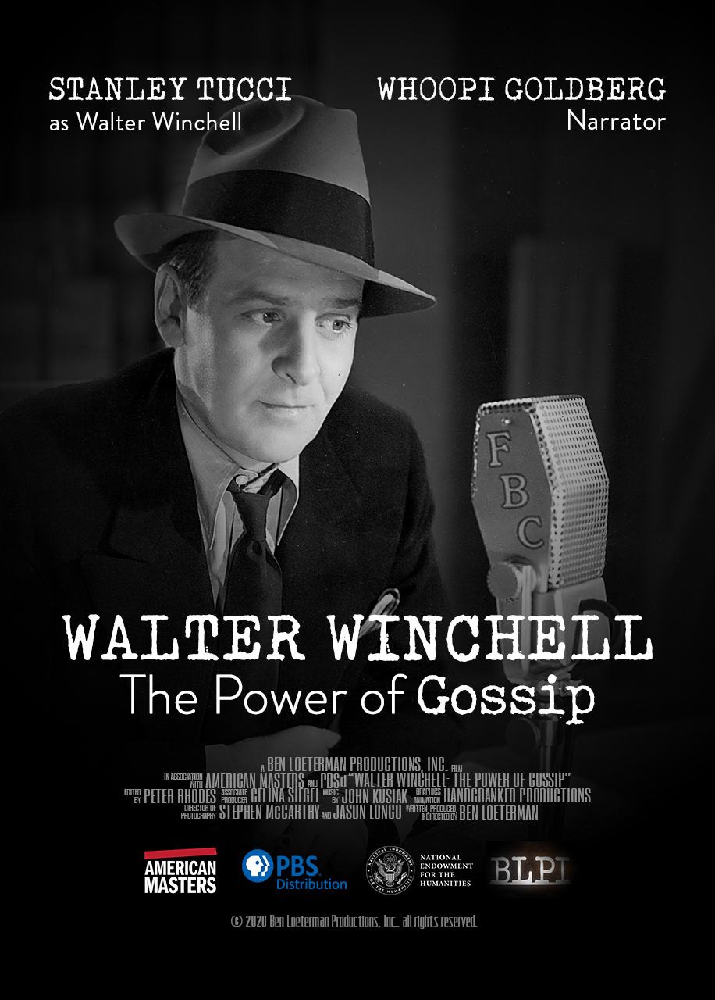

USA • 2020 • 54 minutes • 16:9 • English

Press Inquiries: CaraMar, Inc.
Mary Lugo, lugo@negia.net
Cara White, cara.white@mac.com

walterwinchellfilm.com
About the Film

Short Synopsis

Meet the newspaper columnist, radio commentator and television personality who pioneered the fast-paced, gossip-driven, politically charged journalism that dominates today. At his peak, his audience was 50 million. With Stanley Tucci as the voice of Winchell.

Long Synopsis

Walter Winchell: The Power of Gossip traces the life and career of the syndicated columnist, radio news commentator and television host who pioneered the fast-paced, gossip-driven, politically charged media culture that dominates today. At the height of his career, Winchell had a combined print and radio audience of 50 million — two out of three American adults — and the power to make or break careers. He became the most feared and admired man in America, transforming entertainment journalism and championing “Mr. and Mrs. America” in his daily columns and Sunday night radio program. Decades later, an alliance with Senator Joseph McCarthy and feuds with Josephine Baker and Ed Sullivan turned his audience against him and forced him into obscurity.

Featuring Stanley Tucci as the voice of Winchell and narrated by Whoopi Goldberg, this documentary breathes new life into Winchell’s original newspaper columns and broadcast scripts, drawing on rare recordings and a broad collection of his work in the Billy Rose Theatre Division at The New York Public Library for the Performing Arts. Winchell’s own words comprise nearly a quarter of the script as the film tracks the rise and fall of his career and his continued influence on today’s media. “Walter Winchell is the architect of modern American media,” says biographer and film interviewee Neal Gabler. “He turned journalism into a form of entertainment.”

Director’s Statement

My interest in Walter Winchell grew out of a yearning to better understand the media’s role in our times. News cycles are filled with laudable reportage, but also social comics-cum-news commentators—Howard Stern, Stephen Colbert, Tucker Carlson, Rush Limbaugh, John Oliver, and more. Yet none of them hold a candle to Walter Winchell. He was the original media celebrity, and he created the mold for today’s columnists and commentators.

Neal Gabler’s masterful biography, Walter Winchell: Gossip, Power and the Culture of Celebrity, provides rich insights into his development of today’s media ethos. “Writing that Winchell was ‘arguably one of the principal architects of modern American culture,’” says the New York Times, “Mr. Gabler turns the columnist’s life into the springboard for a fascinating social history.”

Since commencing preliminary research, we’ve built on Gabler’s work to identify key historians whose scholarship expands and illuminates Winchell’s world. Our work includes:

- Interviews: We conducted numerous pre-interviews with scholars, Winchell family members, and descendants of Winchell’s closest associates, ghostwriters Ernest Cuneo and Herman Klurfeld. Like his father, Cuneo’s son Jonathan is a highly connected lawyer in Washington, D.C. Jonathan led us to his father’s sprawling, 1300-page unpublished manuscript, which covers his time as go-between for Winchell and FDR prior to his joining Winchell’s payroll to ghostwrite radio scripts. In addition to granting an interview, Klurfeld’s son, Jim, shared his father’s published biography, the basis for Paul Mazursky’s 1998 HBO film Winchell. Jim has maintained a friendship with Stanley Tucci since their time together on set, and he encouraged us to seek out Tucci, in London, to collaborate with us.

- Biographies: We compared, contrasted, fact-checked, and refracted the points of view of four Winchell biographies— one authoritative and scholarly by Gabler, one by his associate and ghostwriter Klurfeld, one private and exhaustive by Cuneo, and Winchell’s own autobiography. In addition, we made extensive use of two contemporaneous sources: St. Claire McKelway’s longest-ever (six-part) New Yorker profile of Winchell and the New York Post’s infamous 24-part exposé.

- Winchell’s Writing: We planted ourselves at digital microfilm readers at the Billy Rose Theatre Division of the New York Public Library at Lincoln Center, to read and make copies of an extensive collection of Winchell’s early columns, annotated radio scripts, and scrapbooks. These were purchased at auction by Neal Gabler, and donated to the library after several major Journalism schools had “passed,” not wanting to taint their collections with the likes of Winchell.

- Recordings: We located roughly two dozen preserved recordings of Winchell’s broadcasts and rare film footage including Winchell’s first-ever film appearance, an 11-minute vignette filmed in 1930 at Vitaphone Studios in Queens. The short, titled Bard of Broadway, reveals Winchell’s already-fully-formed Broadway persona.

Several historians have emphasized the centrality of Winchell as a cultural pillar of 20th century America. My aim, as a journalistic filmmaker, is to present varying perspectives, employing stylish filmmaking techniques and high-production values, including animating Winchell’s words on-screen to convey his points.

“Twitter is a kind of 21st-century telegraph,” historian John Meacham wrote, “bringing us bursts of news and opinion with little to no context, appealing to the emotions rather than to the intellect…Cable news offers up dramatic serials, entertaining in their twists and turns and outsize characters” – this last part in direct reference to our current president. It’s still Walter Winchell’s world, Meacham concluded. “The rest of us are just living in it.”

Ben Loeterman, September 2020

About the Interview Subjects

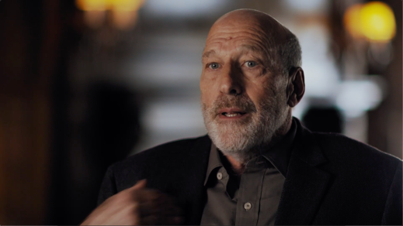
Daniel Czitrom is Professor of History on the Ford Foundation at Mount Holyoke College, focusing on the history of media and of New York City. He is author most recently of New York Exposed: The Gilded Age Police Scandal That Launched the Progressive Era.

Learn more about Daniel’s work
Learn more about New York Exposed

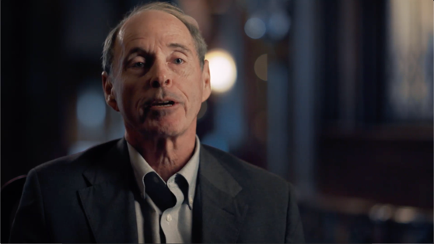
Thomas Doherty is a professor of American studies at Brandeis University and the author of Show Trial: Hollywood, HUAC, and the Birth of the Blacklist (2018) and Little Lindy Is Kidnapped: How the Media Covered the Crime of the Century (2020).

Learn more about Little Lindy is Kidnapped
Learn more about Show Trial

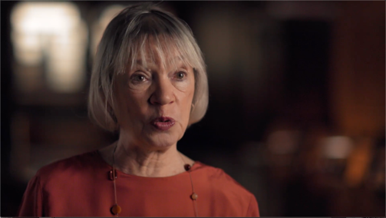
Susan Douglas is a scholar of American media at the University of Michigan, with a focus on historical media and the relationship between gender and media. She is the author of Listening In: Radio and the American Imagination.

Learn more about Susan’s work
Learn more about Listening In

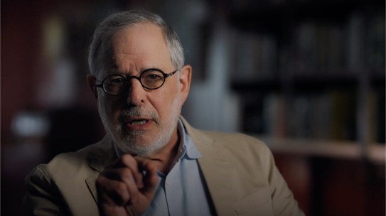
Neal Gabler is the author of Winchell: Gossip, Power, and the Culture of Celebrity, considered the definitive biography of Walter Winchell. His most recent book, the Ted Kennedy biography Catching the Wind, is due out in October 2020.

Learn more about Winchell
Learn more about Catching the Wind

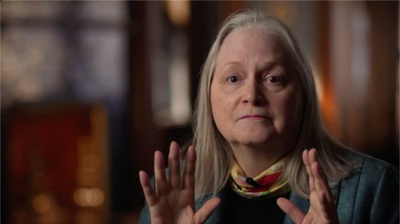
Nancy Gray was married to talk show host Barry Gray from 1986 until his death in 1996. They have one child together, Dora Grace. Winchell set out to destroy Gray's career in the early 1950s after once being his mentor.

Read Barry’s story firsthand

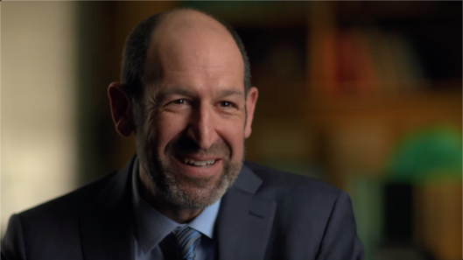
Daniel Greene is the curator of Americans and the Holocaust, a groundbreaking exhibit at the United States Holocaust Memorial Museum which examines the major cultural forces that influenced Americans’ responses to Nazism in the 1930s and 40s. Daniel is currently President of the Newberry Library and an adjunct professor of history at Northwestern University.

Visit the online portion of Americans and the Holocaust
Learn more about Daniel’s book The Jewish Origins of Cultural Pluralism, winner of the American Jewish Historical Society's Saul Viener Prize in American Jewish history

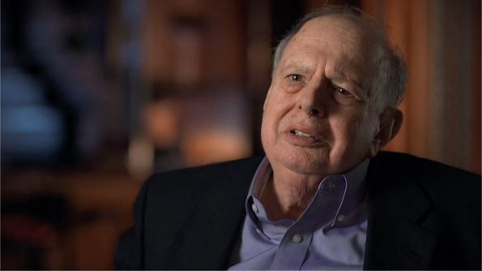
Jim Klurfeld, the former editorial page editor of Newsday, is the son of Herman Klurfeld, Winchell’s ghostwriter for 27 years. In 1970 he was part of the Newsday investigative team which received the Pulitzer Prize for Public Service. He is currently a visiting professor of journalism at Stony Brook University.

Learn more about Jim’s work
Read Herman’s firsthand biography of Winchell

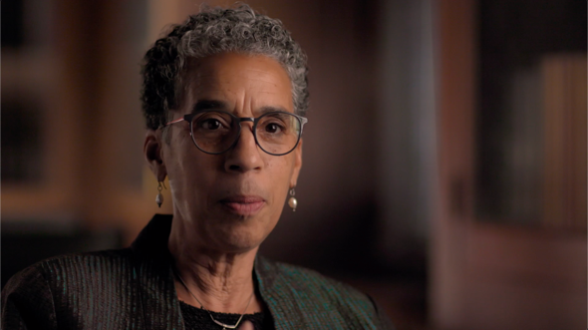
Jane Rhodes is a historian and head of African American Studies at University of Chicago. She focuses on the relationship between African Americans and mass media and provides insight into the history of Black nightlife and the performer Josephine Baker.

Learn more about Jane’s work
Learn more about Mary Ann Shadd Cary
Learn more about Framing the Black Panthers

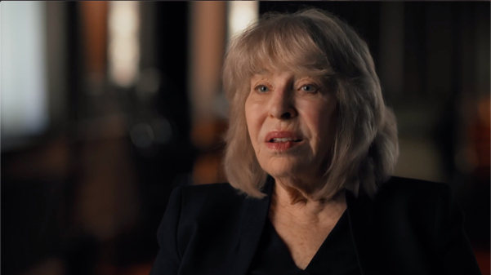
Betty Houchin Winfield is a Professor Emeritus of political communication and mass media history at the University of Missouri School of Journalism. She has authored four books, including the award-winning FDR and the News Media.

Learn more about Betty’s work
Learn more about FDR and the News Media

About the Filmmaking Team

Ben Loeterman (Writer/Producer/Director) is an accomplished writer/producer/ director of public affairs and historical documentaries. He founded Ben Loeterman Productions, Inc. (BLPI) in 1996. 1913: Seeds of Conflict, his NEH-funded film about the origins of today’s Israeli/Palestinian conflict, aired nationally on PBS in 2015. His previous NEH-funded film, The People v. Leo Frank, a Peabody Award finalist, broadcast nationally on PBS in 2009 to critical acclaim.

Loeterman’s work appeared on the first 18 seasons of the PBS series Frontline. He produced programs for PBS/American Experience, including Golden Gate Bridge, Public Enemy #1 and Rescue at Sea. He has received national Emmy Awards for directing and investigative journalism, Amnesty International's Media Spotlight Award, and two duPont-Columbia Journalism Awards. He was a Peabody Award finalist.

Neal Gabler (Adviser) is the definitive biographer and author of Winchell: Gossip, Power, and the Culture of Celebrity (1994). Gabler’s other books include An Empire of Their Own: How the Jews Invented Hollywood, Life the Movie: How Entertainment Conquered Reality, and Walt Disney: The Triumph of the American Imagination. His forthcoming biography of Ted Kennedy is due out this fall. Gabler also teaches at the Stonybrook Southampton MFA program in Creative Writing and Literature.

Stanley Tucci (Walter Winchell) is an actor, writer, director, and producer. He has directed five films and appeared in more than 70 films and a dozen plays on and off Broadway. He has been nominated for an Academy Award, a Tony, and a spoken word Grammy and is the winner of two Golden Globes and three Emmys. He received his first Emmy for his portrayal of Walter Winchell in the 1998 HBO biopic Winchell. His upcoming credits include the films Supernova, The King’s Man, and The Witches.

Whoopi Goldberg (Narrator) is part of an elite group of artists who have won the Grammy, the Academy Award, the Golden Globe, the Emmy, and the Tony. Currently, she is the co-host of ABC’s The View. She is equally well-known for her humanitarian efforts on behalf of children, the homeless, human rights, education, substance abuse, and the battle against AIDS. Among her many charitable activities, Goldberg is a Goodwill Ambassador to the United Nations.

Celina Siegel (Associate Producer) has worked on Walter Winchell: The Power of Gossip since its inception. Previously, she worked as a production assistant on The Feud for PBS/American Experience. Siegel holds a Bachelor of Arts in Cinema Studies from Oberlin College.

Peter Rhodes (Editor) has edited dozens of films for PBS and the BBC, as well as several independent documentary features. His extensive edit work with Ben Loeterman includes War & Oil (The Prize, 1992), Who Was Lee Harvey Oswald? (Frontline, 1993), Apocalypse! (BBC/Frontline, 1999), Real Justice (BBC/Frontline, 2000), Public Enemy #1 (American Experience, 2000), The War That Made America (2004), and John Portman: A Life of Building (2011).

Stephen McCarthy (Co-Director of Photography) has served as director of photography for many PBS programs, including American Experience, American Masters, Frontline, Nova, and P.O.V. Recent accomplishments have included work on two Emmy-nominated PBS series: Cancer: The Emperor of All Maladies and Your Inner Fish. He is also a visiting lecturer on cinematography at Boston University, Rhode Island School of Design, the Maine Media Workshops, and MIT's graduate program in science writing.

Jason Longo (Co-Director of Photography) is an Emmy-winning cinematographer, editor, and director. Longo has photographed over 100 documentary films and televisions programs in 55 countries on six continents. He is a frequent contributor to the PBS series Frontline, NOVA, and American Experience, as well as to The Discovery Channel, National Geographic, and The History Channel.

Bryan Papciak (Graphics Animator) has collaborated with Loeterman on several films, including the critically acclaimed The People v. Leo Frank (2009) and John Portman: A Life of Building (2011). He is a founder of Handcranked Productions, an independent film/animation company, and has worked with commercial clients Samsung, MTV, HBO, Cartoon Network, PBS, Sesame Street, and many others. He has been a member of the RISD faculty since 2002.

John Kusiak (Composer) has composed and produced music for film, television, advertising, and live performance – including several award-winning documentaries. Clients have included HBO (The Jinx), Netflix (Team Foxcatcher), IFC (First Person), and PBS (American Experience). In 2012 he won the Cinema Eye Honors Award for Outstanding Achievement in Original Music Score for his score for Errol Morris’ Tabloid.

Credits

Narrator
Whoopi Goldberg

Stanley Tucci as
Walter Winchell

Written, Produced and Directed by
Ben Loeterman

Editor
Peter Rhodes

Associate Producer
Celina Siegel

Cinematography
Stephen McCarthy
Jason Longo

Composer
John Kusiak

Animation
Handcranked Productions

Line Producer
Ellen Golbranson

Archival Producer
Heather Merrill

Sound
Rich Pooler, Steve Bores
Sam Kashefi, Mark Mandler
Gil Ben Zeev

Additional Camera
Joseph Edwards

Field Producer
Nancy Gifford
Hazel Thompson

Post-Production Editor
Nina Kotyantz

Assistant Editor
Matt Shelley-Reade
Danny Garfield

Production Assistant
Gaia De Simoni
Hallie Fernsebner, Cora Hankey,
Sasha Schell, Natasha Zünd

Re-Recording Mixer
Greg McCleary

Audio Post-Production
Heart Punch Studio

Colorist
Brandon Kraemer

Video Post-Production
The OutPost @ WGBH

Advisers
Neal Gabler
Dan Czitrom, Thomas Doherty, Susan Douglas
Daniel Greene, Jane Rhodes, Betty Houchin Winfield

Clearance Counsel
Donaldson + Callif, LLP
Michael C. Donaldson, Esq.
Alexandre M. Yousefzadeh, Esq.

Copyright Research

Elias Savada

Special Thanks
Kurt Andersen, Arnie Bernstein
Marcia Bradfield, Gonzalo Chacon
Mat Flasque, Joe Lauro
Doug Reside, Annemarie van Roessel
Ben Proudfoot, Terry Quennell

